**Assignment -1**

Digital Marketing

|  |  |
| --- | --- |
| Student Name | Kaviyapriya p |
| Student Roll Number | 20UBCS001 |
| NM ID | E132BB6CE6D7CFF96F4467D09FE23BB4 |
| College Name | AAA College of Engineering and Technology |

**QUESTION:**

**Create a blog or website using Blogspot and WordPress. Customize the theme design and post new article with 500 words.**

**BLOG USING BLOGSPOT:**

**Blog link:** https://kaviyahennadesign.blogspot.com/2023/08/kaviya-artist-henna-art-also-known-as.html

**Blog Title: Kaviyahennadesign**

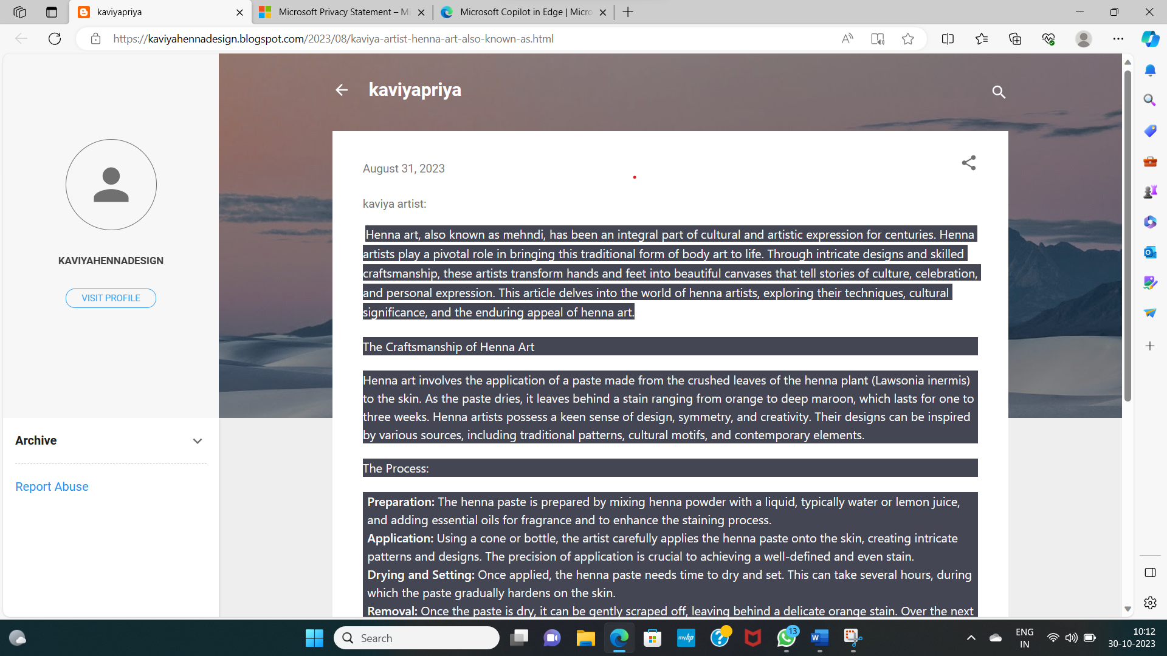

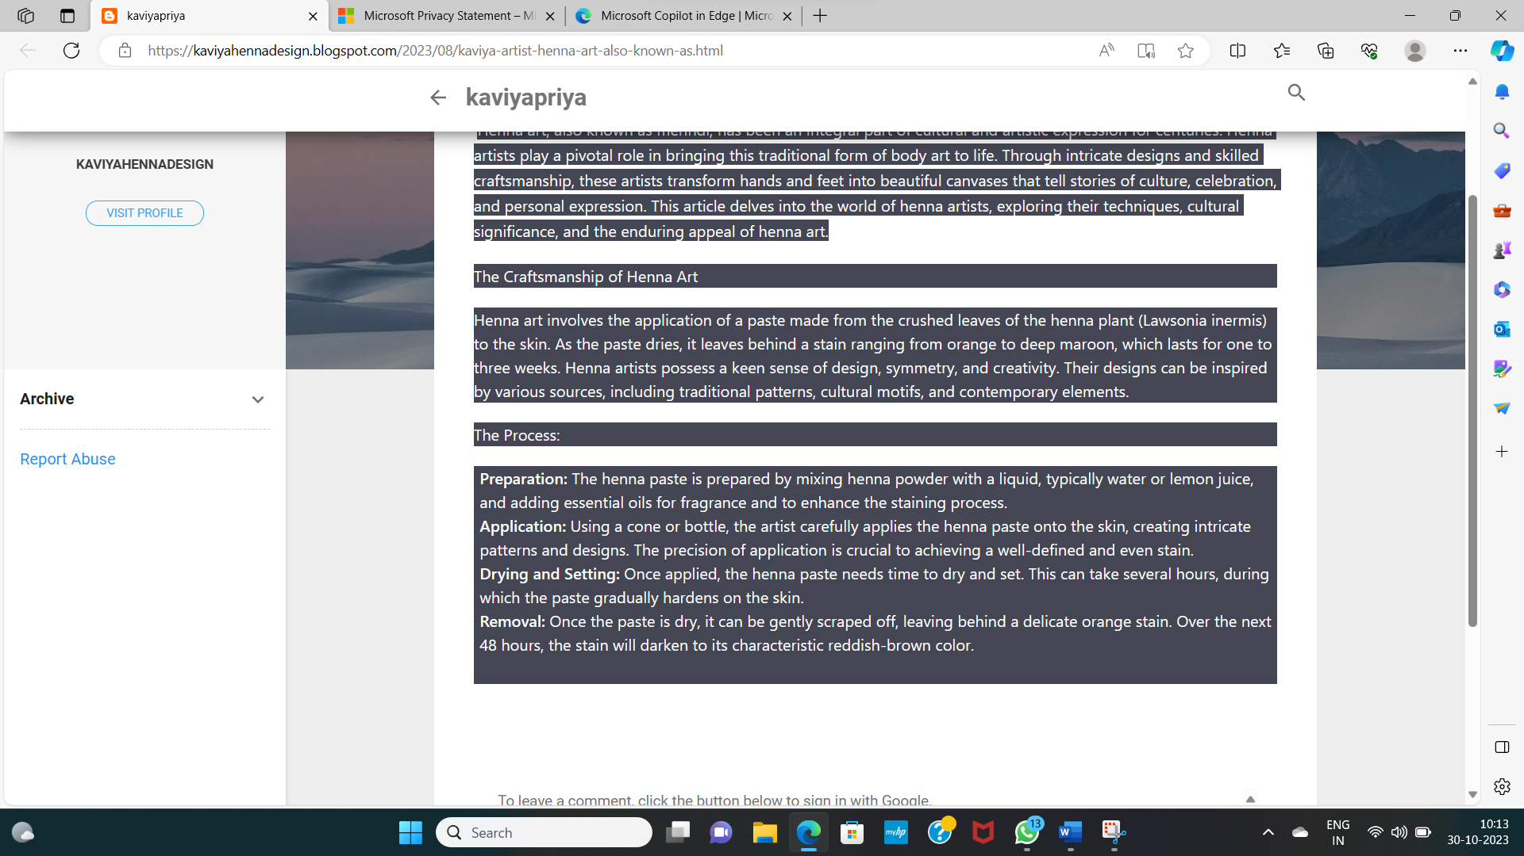

**BLOG USING WORDPRESS:**

**Wordpress link:** [Your Site ‹ Site Title — WordPress.com](https://wordpress.com/view/21urme032.wordpress.com)

**Blog Title: Kaviyahennadesign**

